# Name: Wai Lok Cheng 11408380

# Cougar Club Survey

This document specifies the requirements of the requested cougar club survey. The purpose of this survey is because the WSU fan club’s president, Joe Coug wants to reach out to the other club members. It is a great opportunity for Joe to get to know more about his club members. After this survey, Joe will get to know more about each one of you in the WSU fan club, and it will expend the network between you and Joe in this WSU club. This survey is created for each of the WSU fan club member to fill. In the result of the survey, Joe will have a chance to get to know you more than just attending to the club meeting.

# System Requirements

Use Case: Submit Survey

Participants: Initated by Joe Coug  
 commit by the WSU fan club’s members

Flow of events 1. WSU fan club’s members Get to the website of the survey  
 2. Start the survey by inserting personal information  
 3. Follow by inserting answers for the questions  
 4. Click the summit button on the bottom of the survey  
 5. Survey receive by Joe Coug

Entry condition 1. Have a computer with internet access  
 2. Time to fill out the survey

Exit condition 1. WSU fan club’s member submitted the survey

Quality requirements 1. Internet must stay connect until the survey is submit

Functional requirements: The survey must work on all major browser  
 The survey must work on a mobile phone browser

Non-functional requirements: The survey shall have cool colors

Diagram of the system: 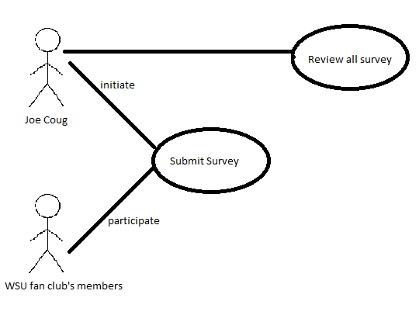

## Scenarios

Finishing and submitting the survey  
Finding email on the survey page to send email to Joe Coug

## Use Cases

Submit survey  
Send email to Joe Coug

## Functional Requirements

Survey must get volunteer’s name  
Survey must get volunteer’s class standing  
Survey must ask volunteer’s Major  
Survey must get volunteer’s email  
Survey must ask volunteer for their graduation time

## Non Functional Requirements

Survey shall designed in cool color  
Survey shall ask for their (school) work load (busy or not)  
Survey shall not be bound by any timer  
Survey shall find their list of interest  
Survey shall not connecting member from other members

## Figures

Use case diagram: Send email to Joe Coug

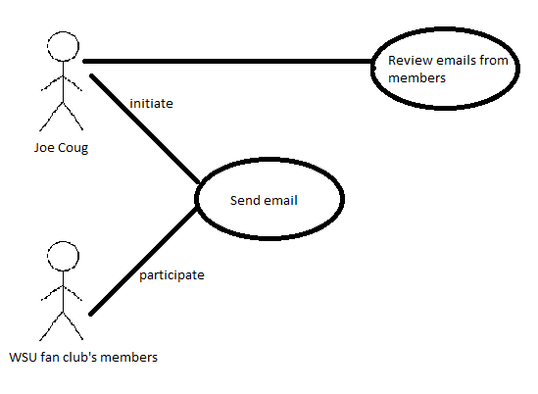

Brief sketch of the system:

